재정 상담 프로그램

● 요구 사항

14쪽의 재정 상담 프로그램을 저축은 3만불, 수입은 3만 5천불, 부양 가족은 3명으로 수정해서 할 것.

● 출력 결과

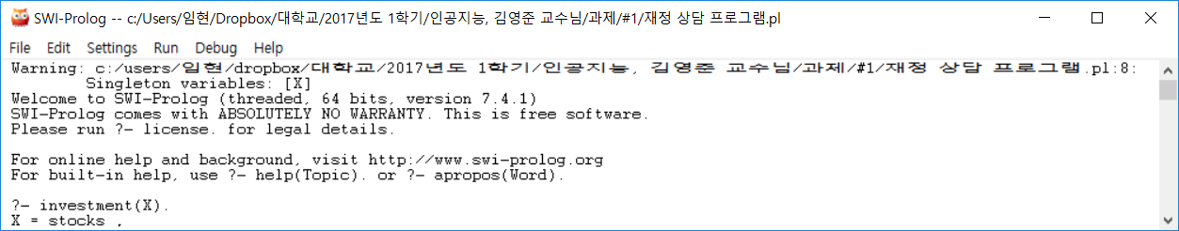

● 소스 코드

investment(savings):-savings_account(inadequate).

investment(stocks):- savings_account(adequate), income(adequate).

investment(combination):- savings_account(adequate), income(inadequate).

savings_account(adequate):- amount_saved(X), dependents(Y), X > 5000*Y.

savings_account(inadequate):- amount_saved(X),dependents(Y),X=<5000*Y.

income(adequate):-earnings(X, steady), dependents(Y), X > 15000+4000*Y.

income(inadequate):- earnings(X, steady), dependents(Y), X =< 15000+ 4000*Y.

income(inadequate):- earnings(X, unsteady).

amount_saved(30000).

earnings(35000, steady).

dependents(3).

knight's tour problem

● 요구사항

L은 저장경로, 5x5로 해서 출발점을 정하고, 도착점을 어떻게 가는지.

● 출력 결과

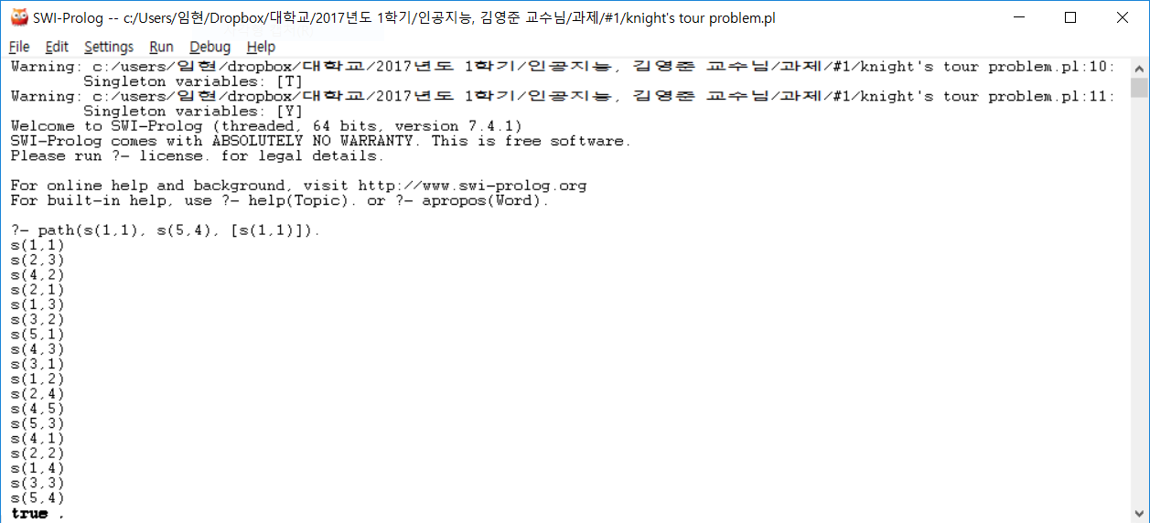

● 소스 코드

move(s(X,Y),s(W,Z)):- W is X+2, Z is Y-1, X+2<6, Y-1>0.

move(s(X,Y),s(W,Z)):- W is X+1, Z is Y-2, X+1<6, Y-2>0.

move(s(X,Y),s(W,Z)):- W is X-1, Z is Y-2, X-1>0, Y-2>0.

move(s(X,Y),s(W,Z)):- W is X-2, Z is Y-1, X-2>0, Y-1>0.

move(s(X,Y),s(W,Z)):- W is X-2, Z is Y+1, X-2>0, Y+1<6.

move(s(X,Y),s(W,Z)):- W is X-1, Z is Y+2, X-1>0, Y+2<6.

move(s(X,Y),s(W,Z)):- W is X+1, Z is Y+2, X+1<6, Y+2<6.

move(s(X,Y),s(W,Z)):- W is X+2, Z is Y+1, X+2<6, Y+1<6.

member(X,[X|T]).

member(X,[Y|T]):- member(X,T).

reverse_writelist([]).

reverse_writelist([H|T]):- reverse_writelist(T), write(H), nl.

path(s(X,Y),s(X,Y),L):- reverse_writelist(L).

path(s(X,Y),s(G,H),L):- move(s(X,Y),s(W,Z)), not(member(s(W,Z),L)), path(s(W,Z),s(G,H),[s(W,Z)|L]).